**01/08/2024 :** Intro to DevOps

1 ) Create DevOps Diagram

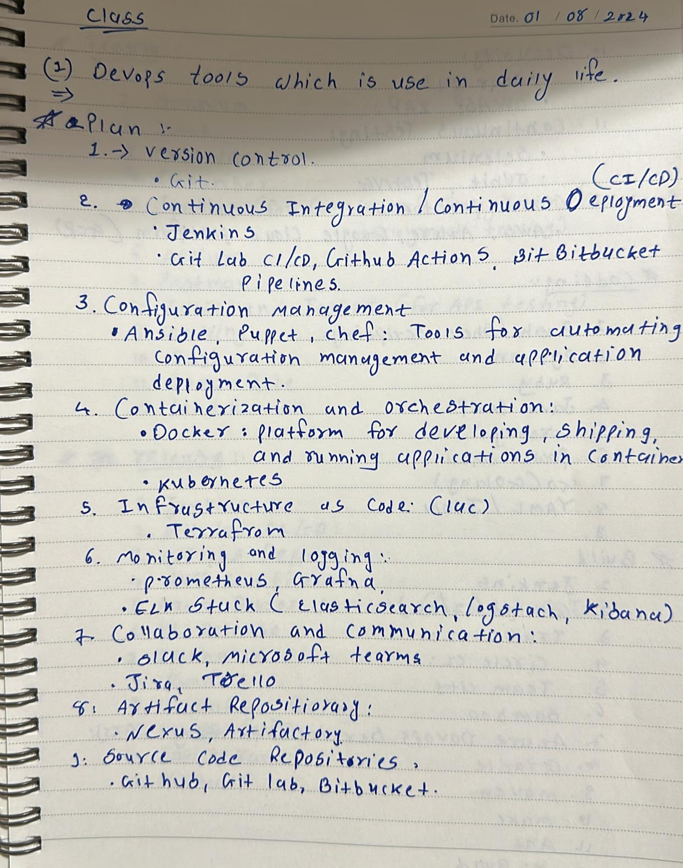

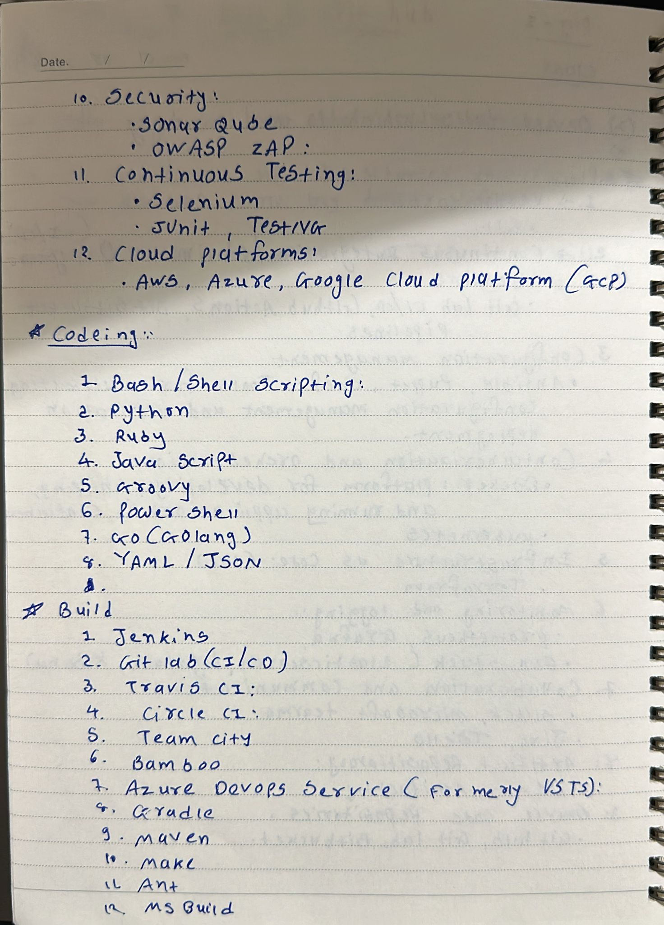

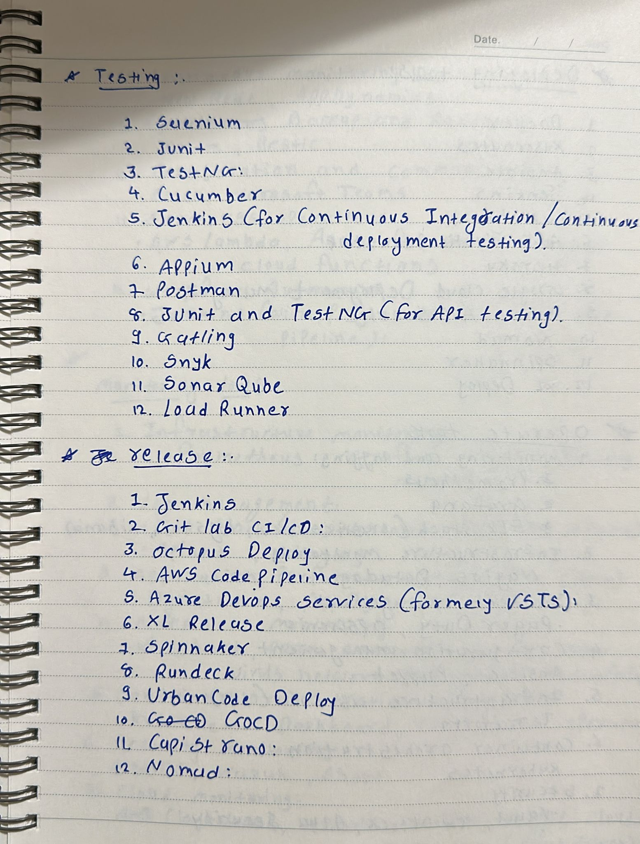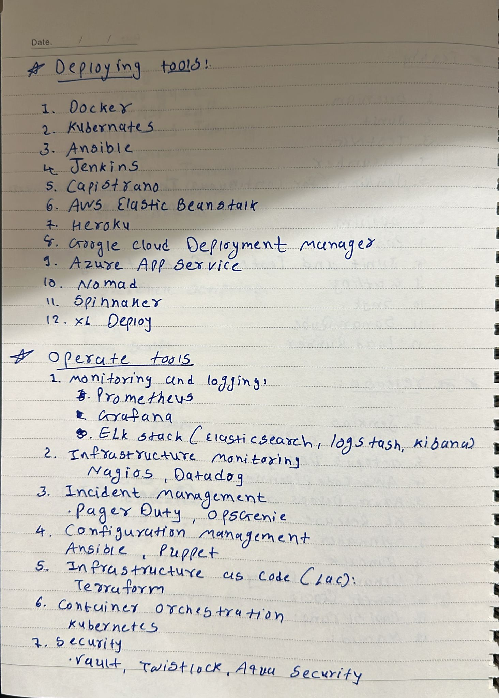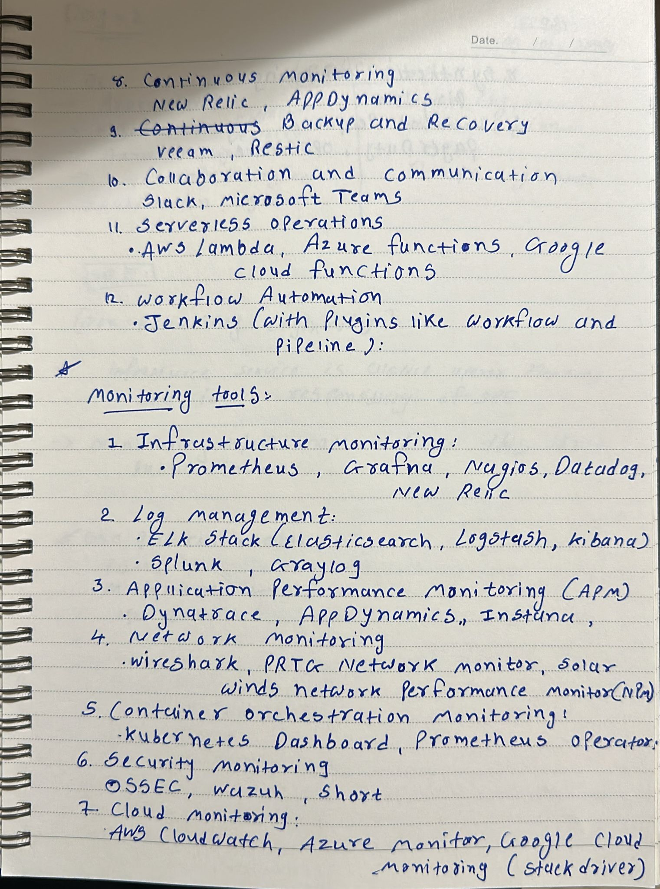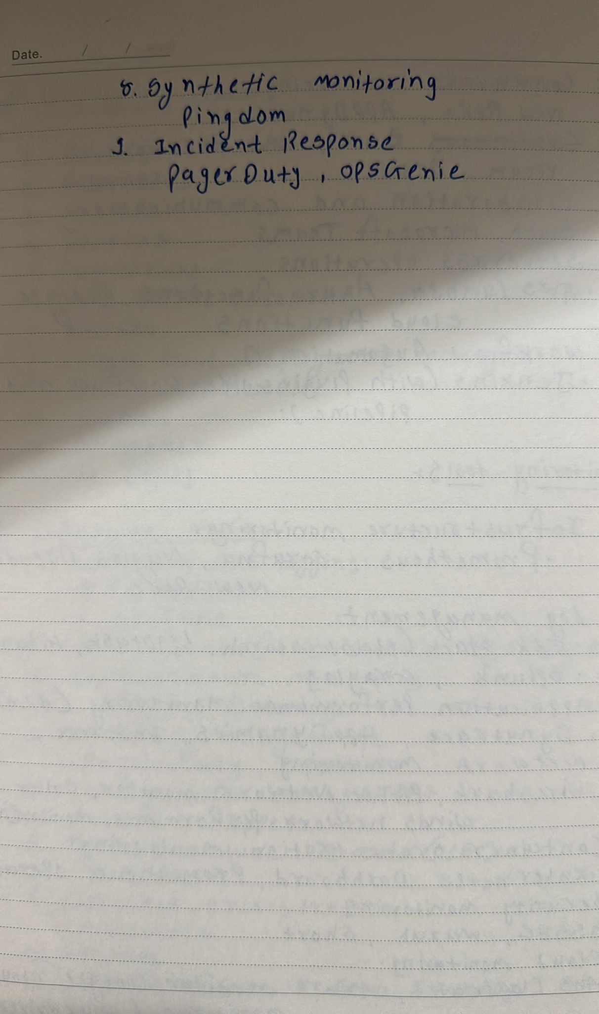2) 2 ) 2) Create AWS Account

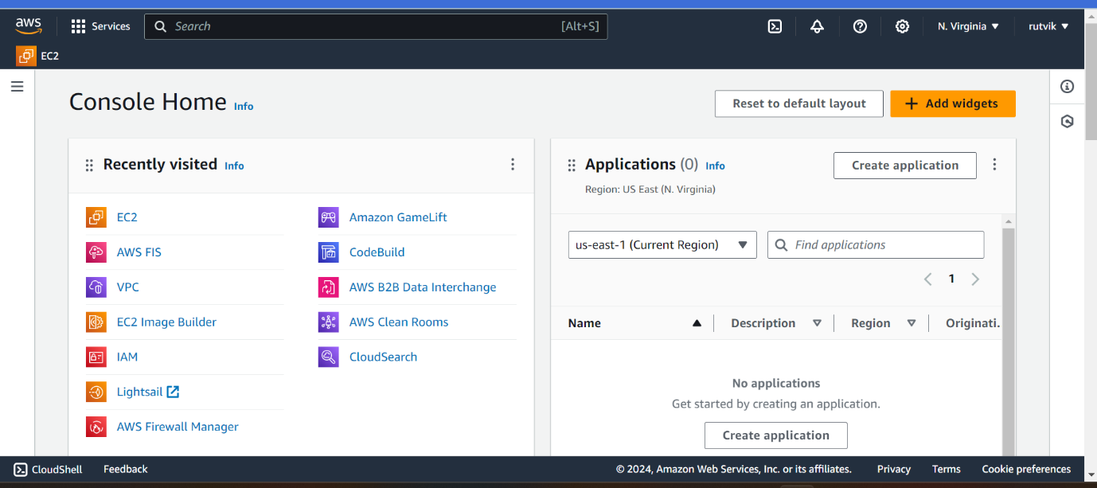

3) Install VS Code

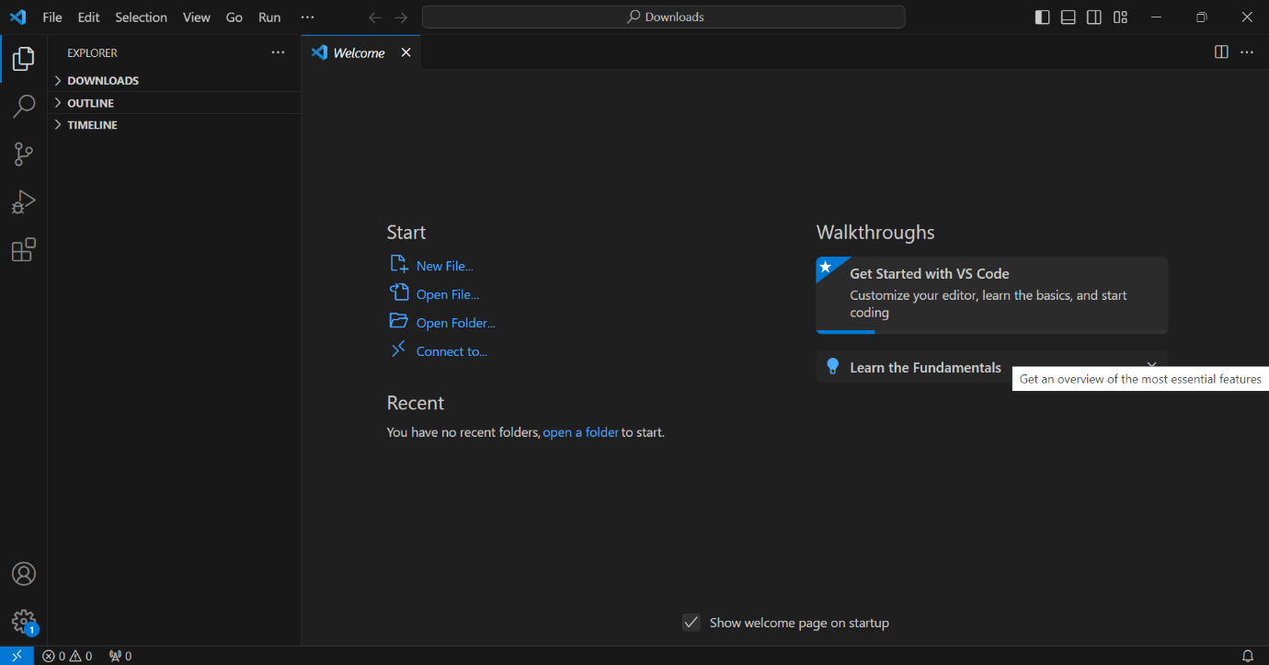

**01/09/2024:** Intro to Cloud

1. Create EC2 in AWS Account

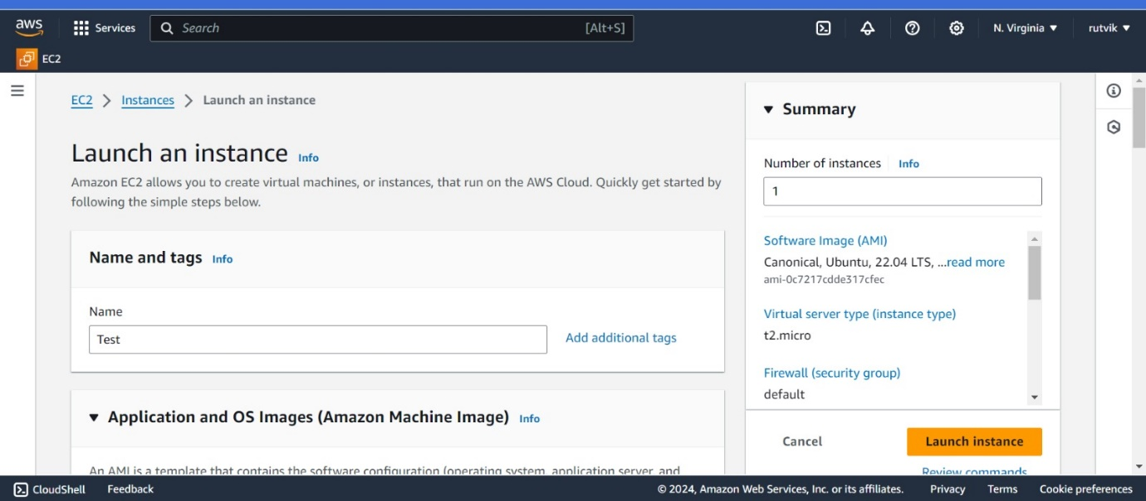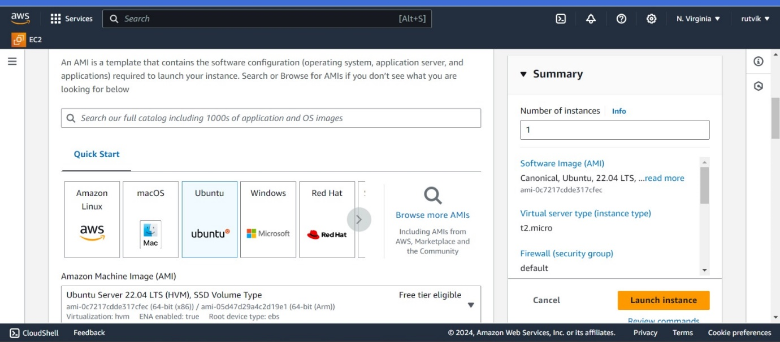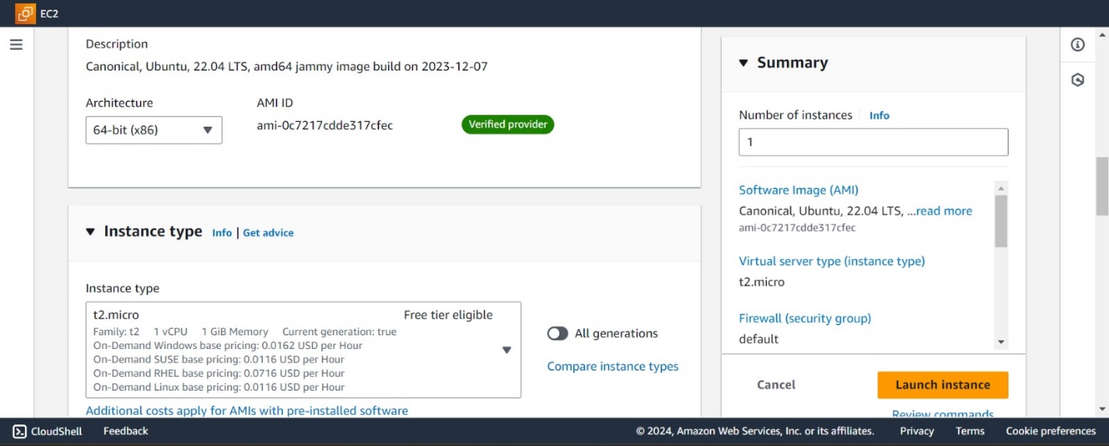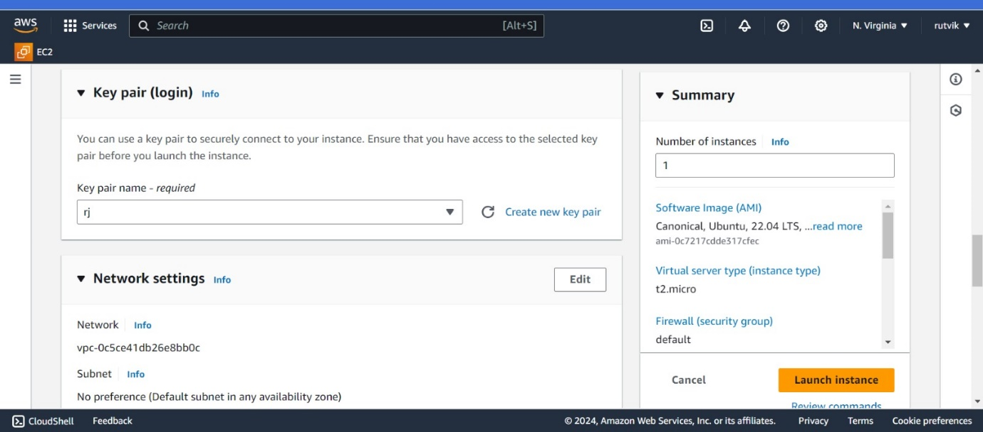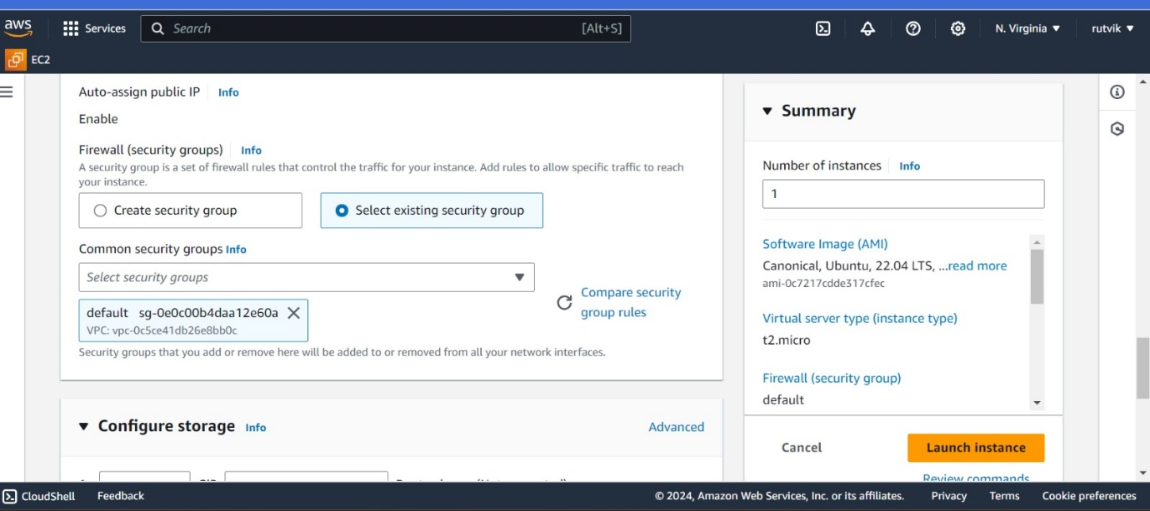 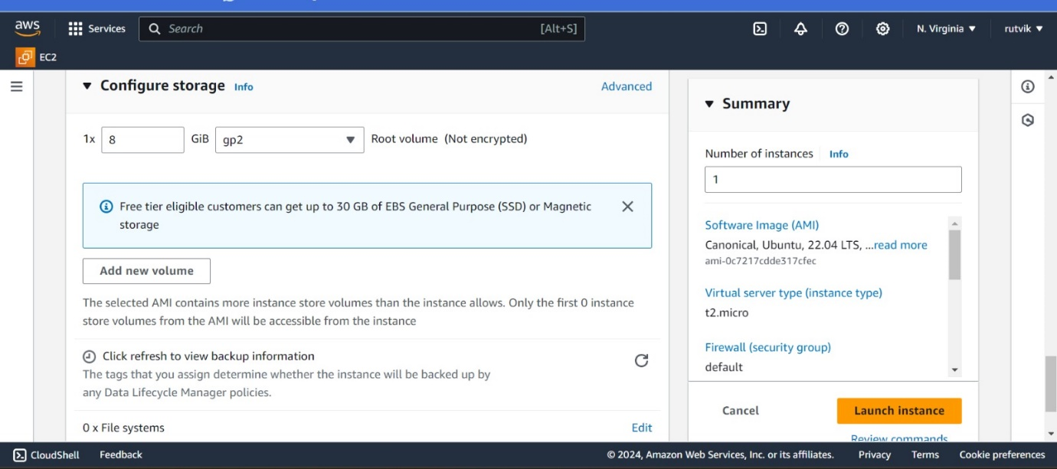

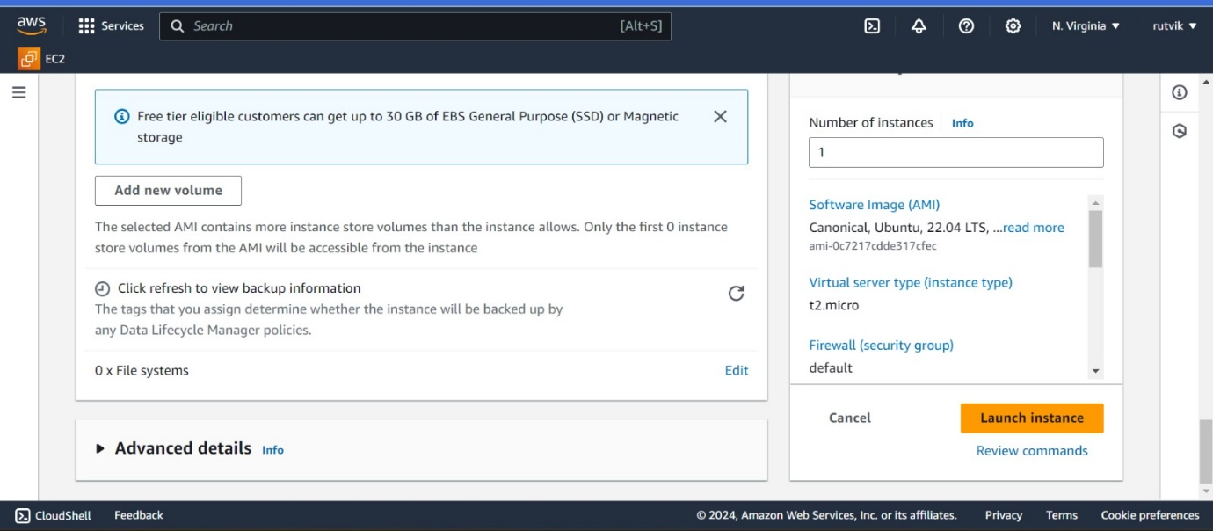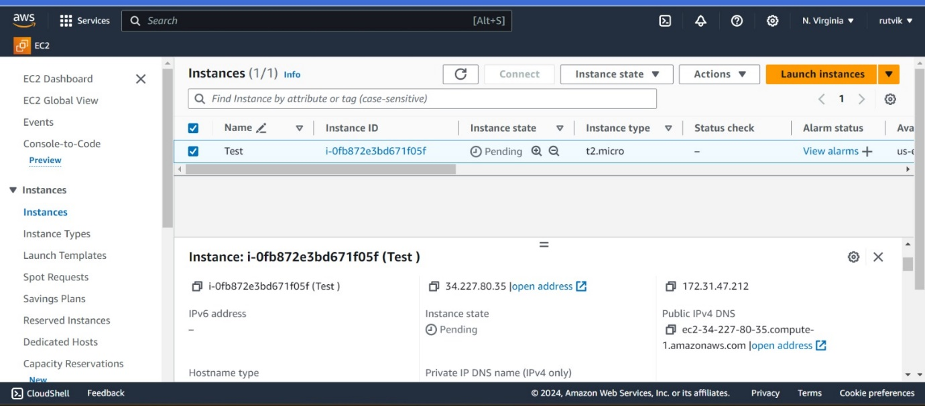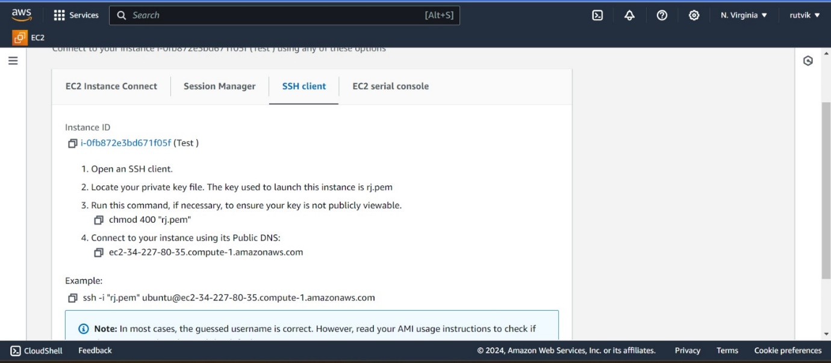

1. Connect to Linux EC2 from local Machine

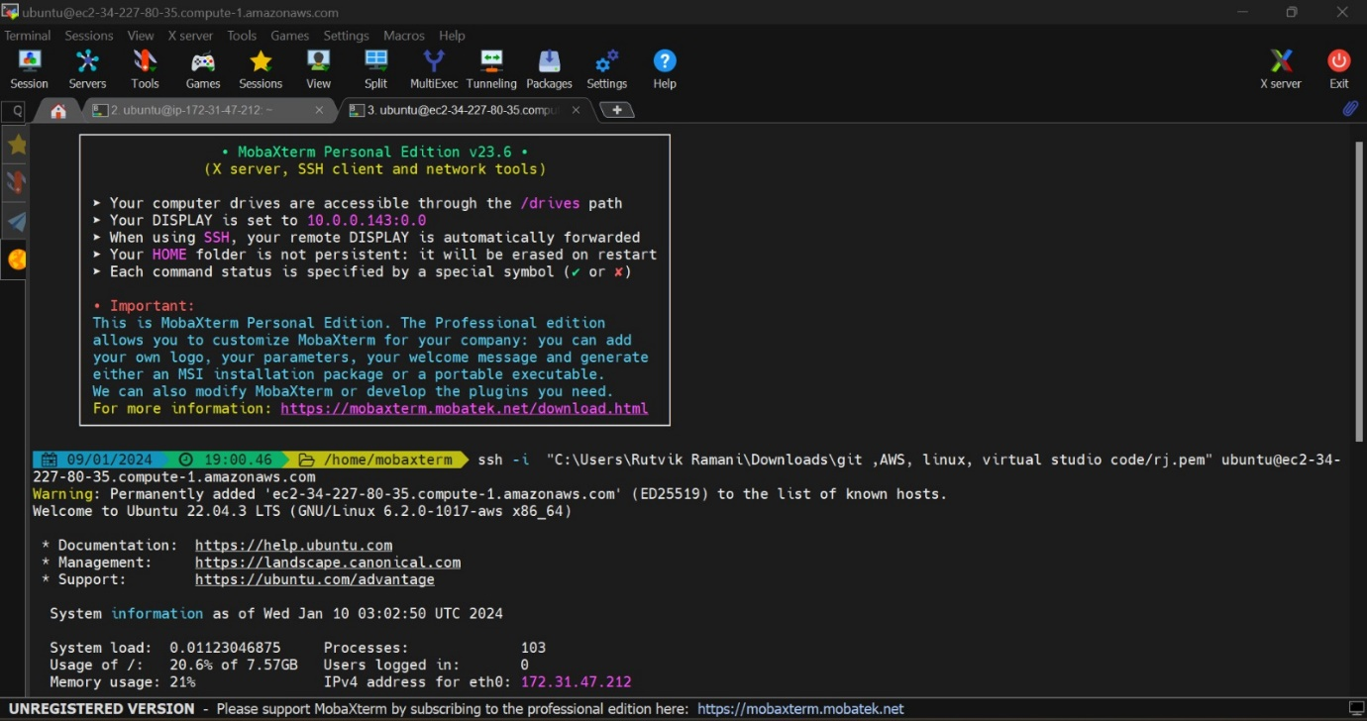

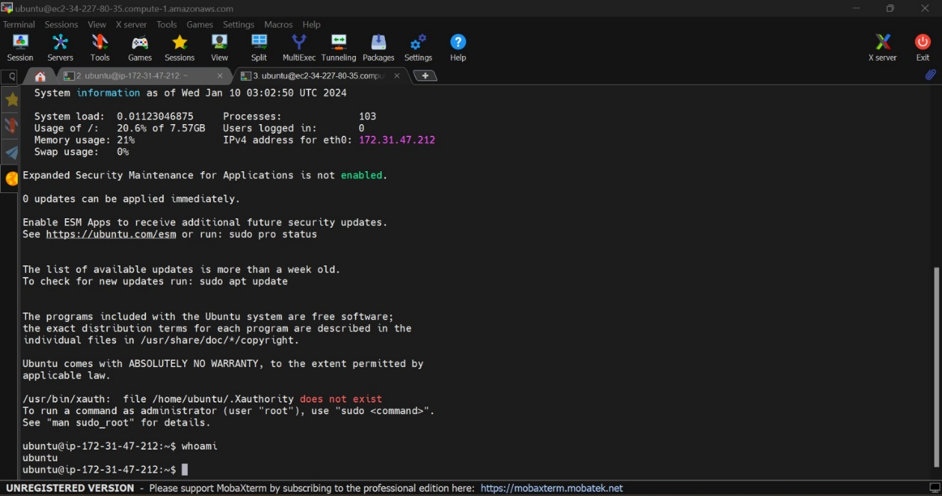

**01/10/2024 :** Intro to Network Agile

1. Understand and Create VPC

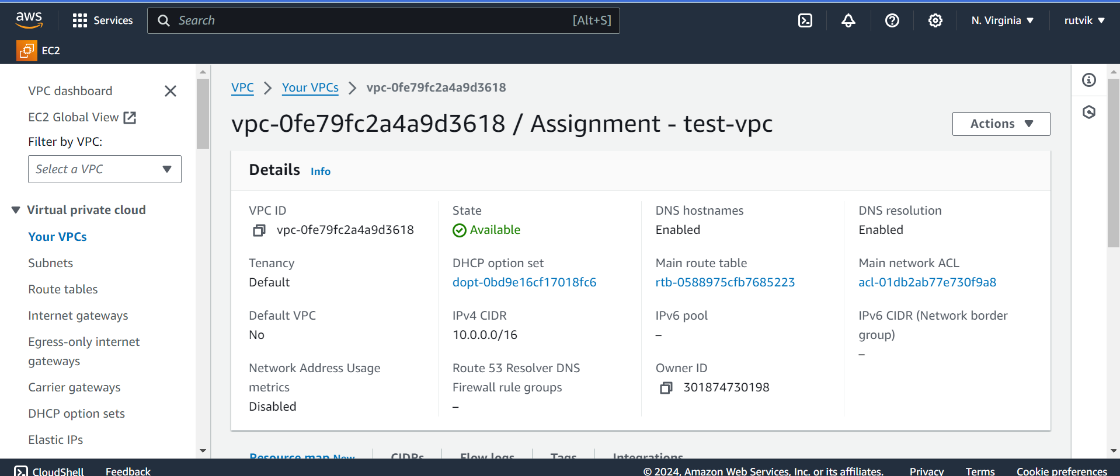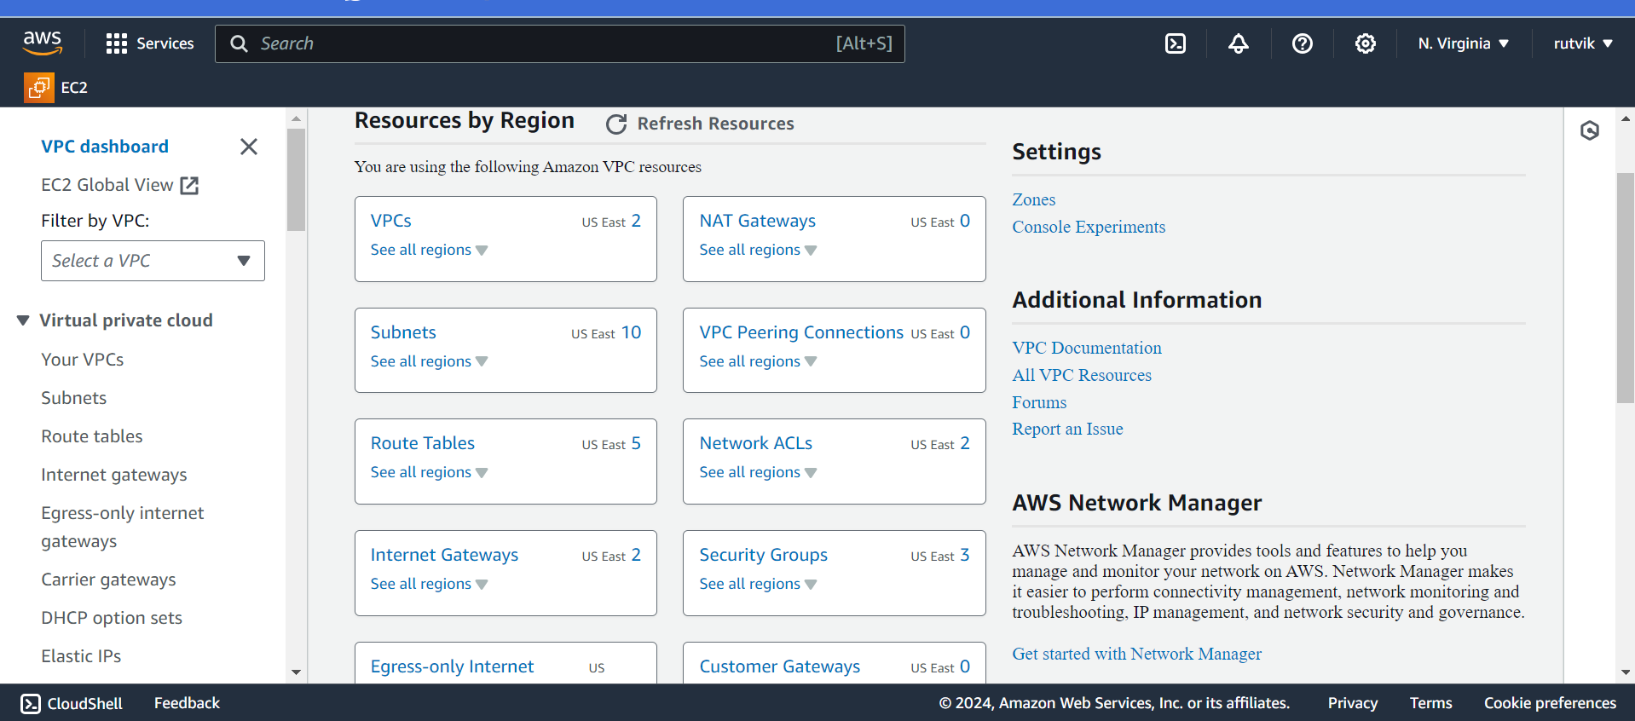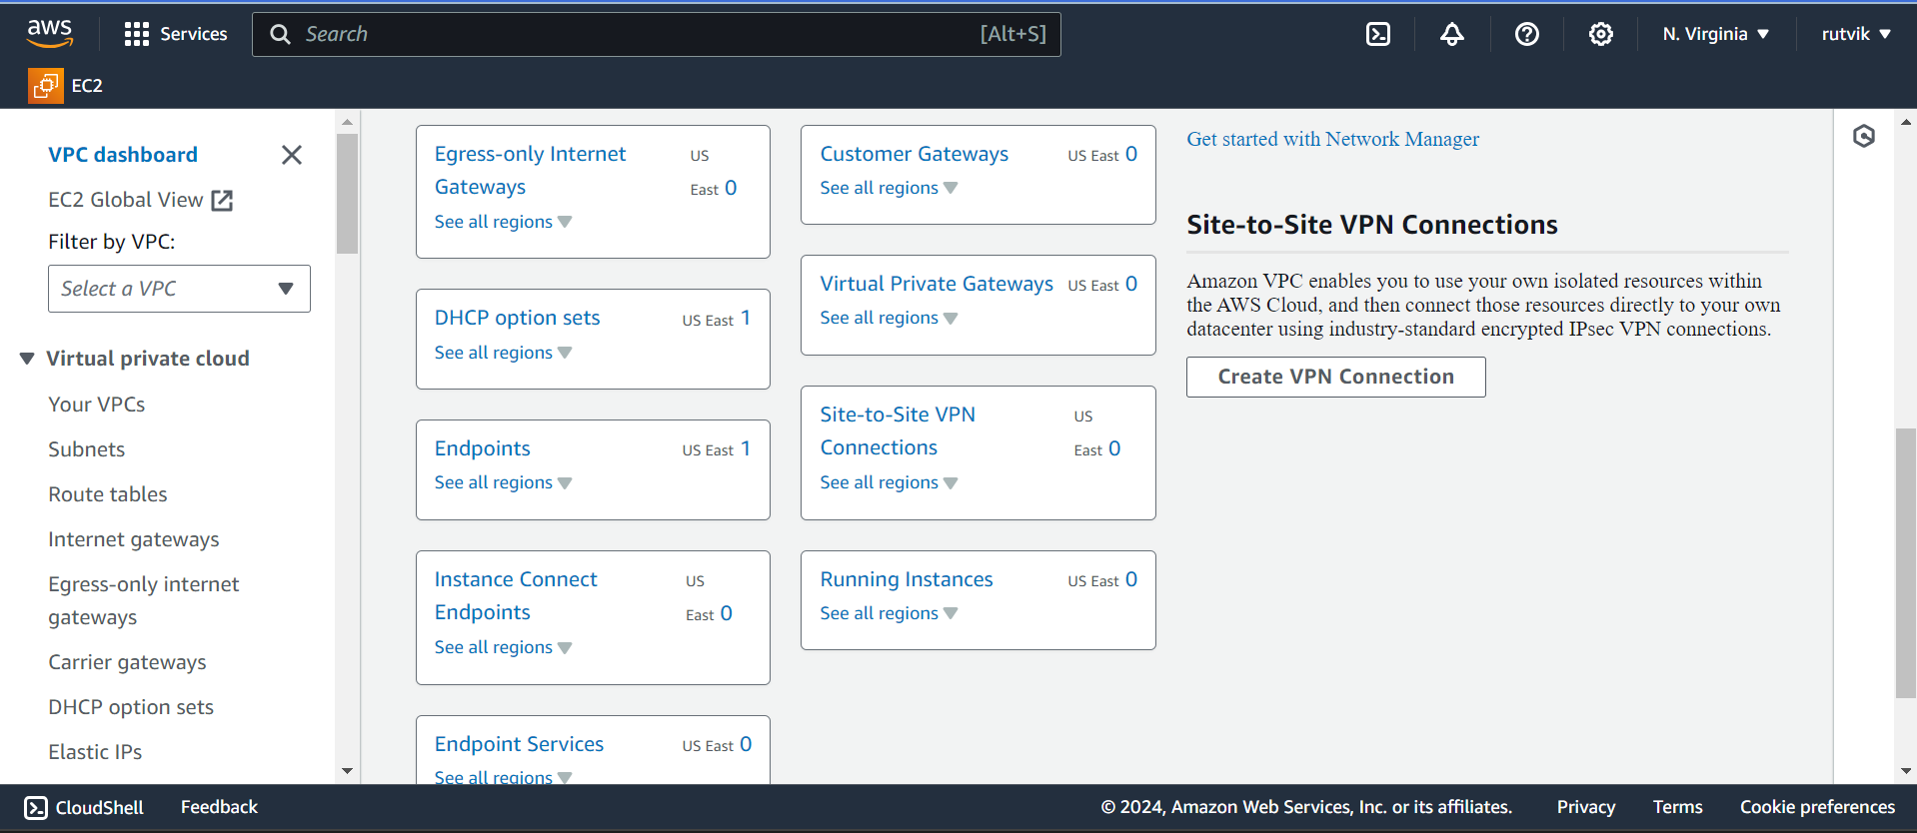

**01/11/2024 :** Networking

Create Disaster Recovery Diagram for EC2

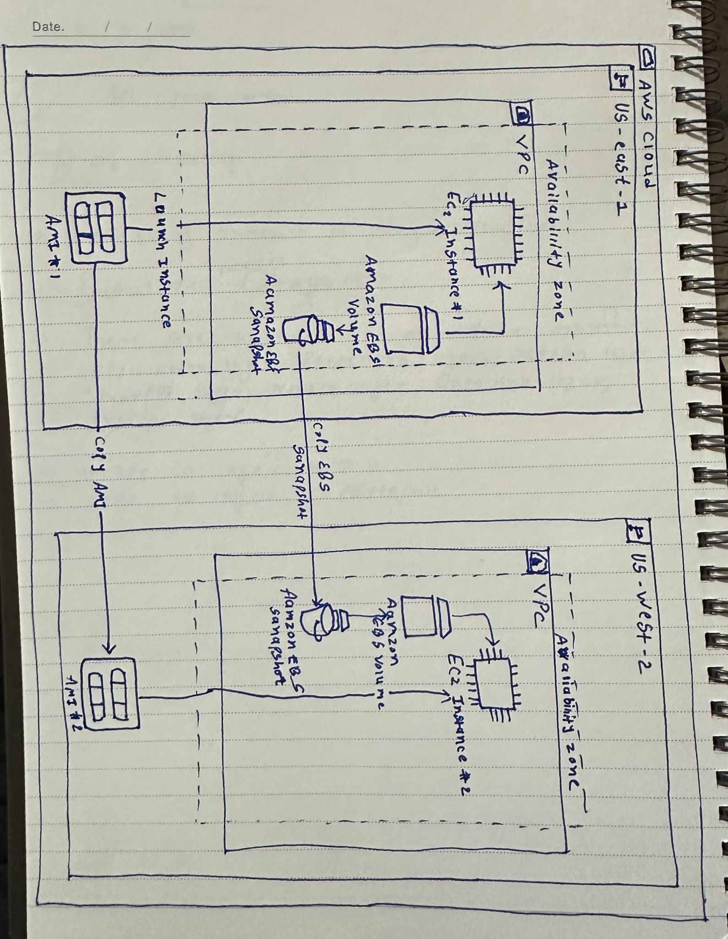

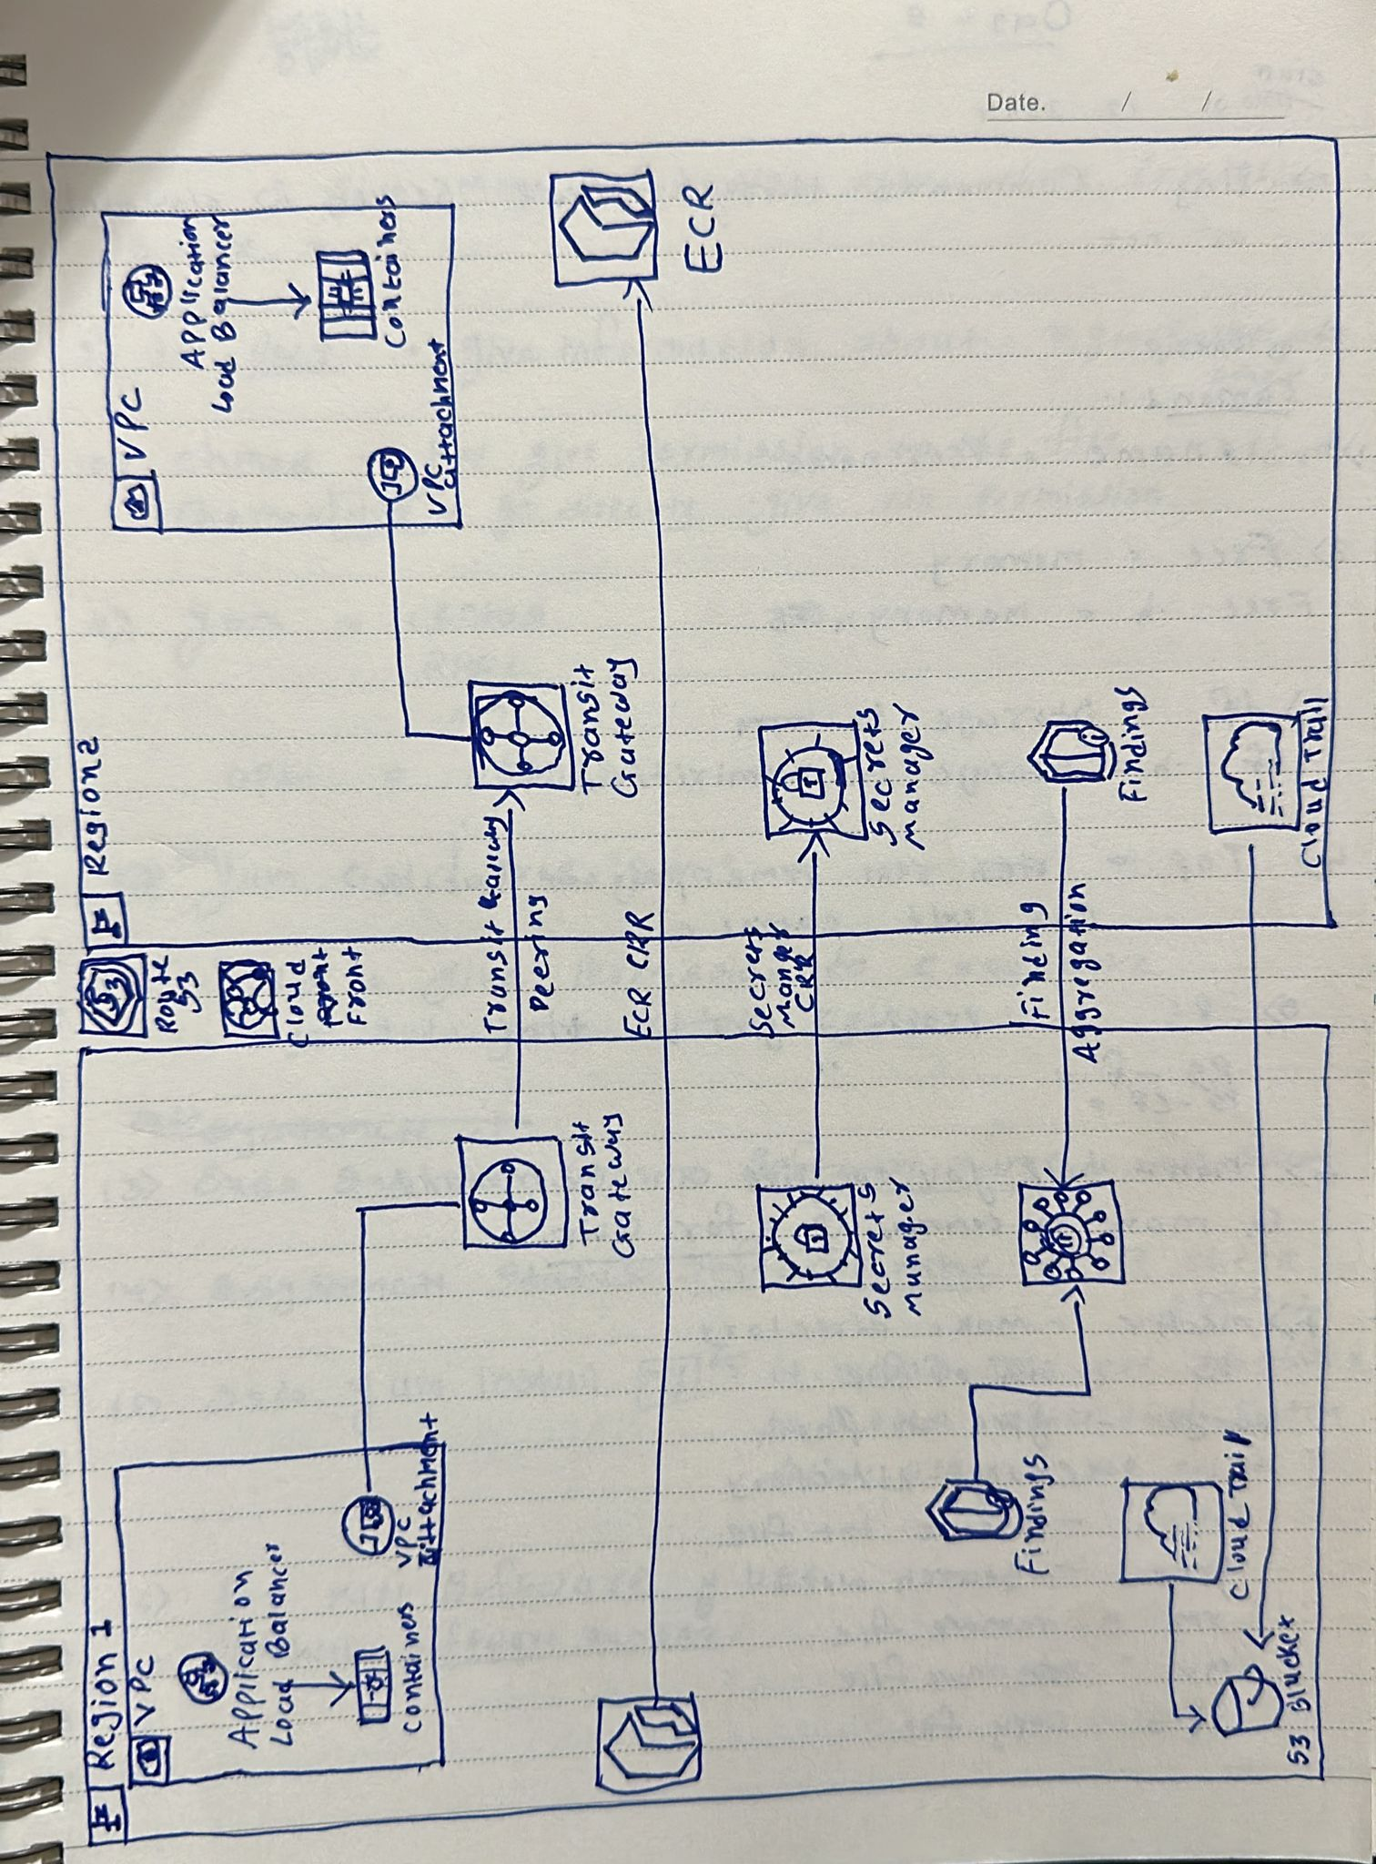

**01/12/2024 : linux**

1. Find all files in entire machine ending with .txt and remove them

For Find : find / -type f -name "*.txt"

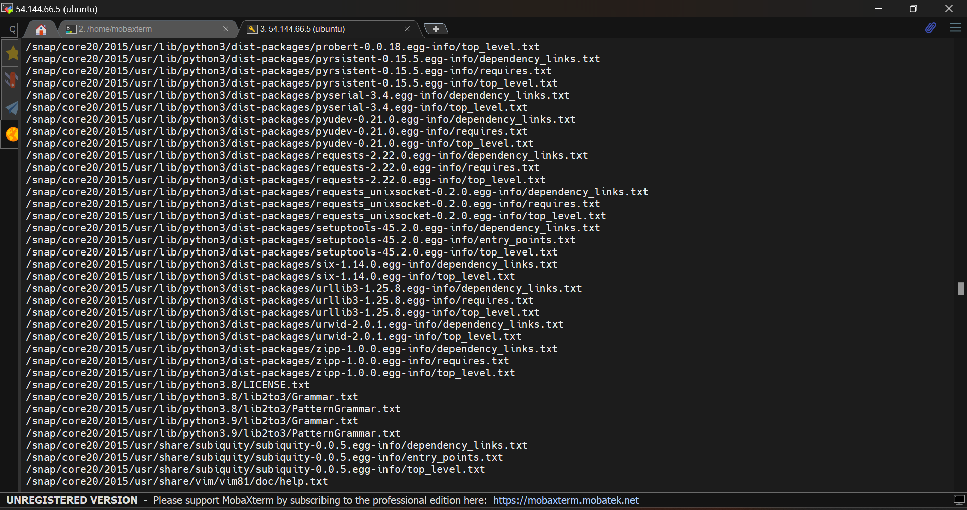

Command : find -type f -name "*.txt" -exec rm {} \;

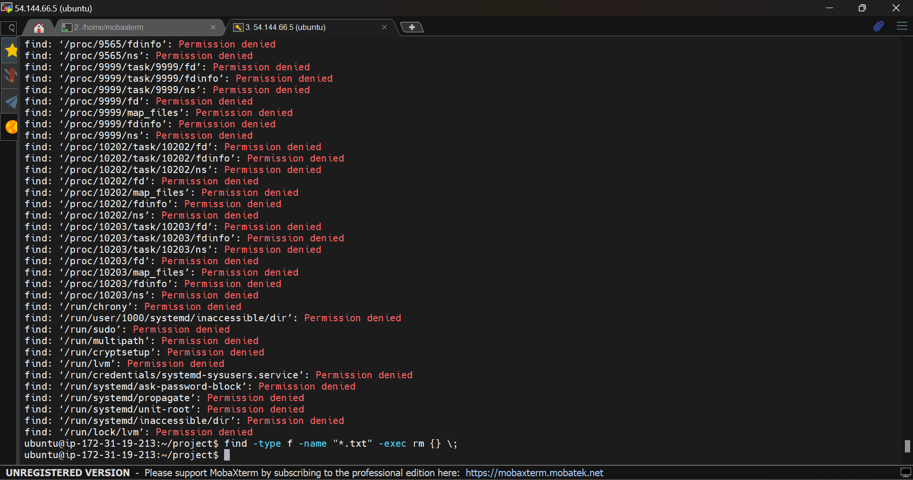

1. Find 10th record of var/log/audit/access.log file

PWD : home/var/log/audit/audit.logs

Give permission by chmod

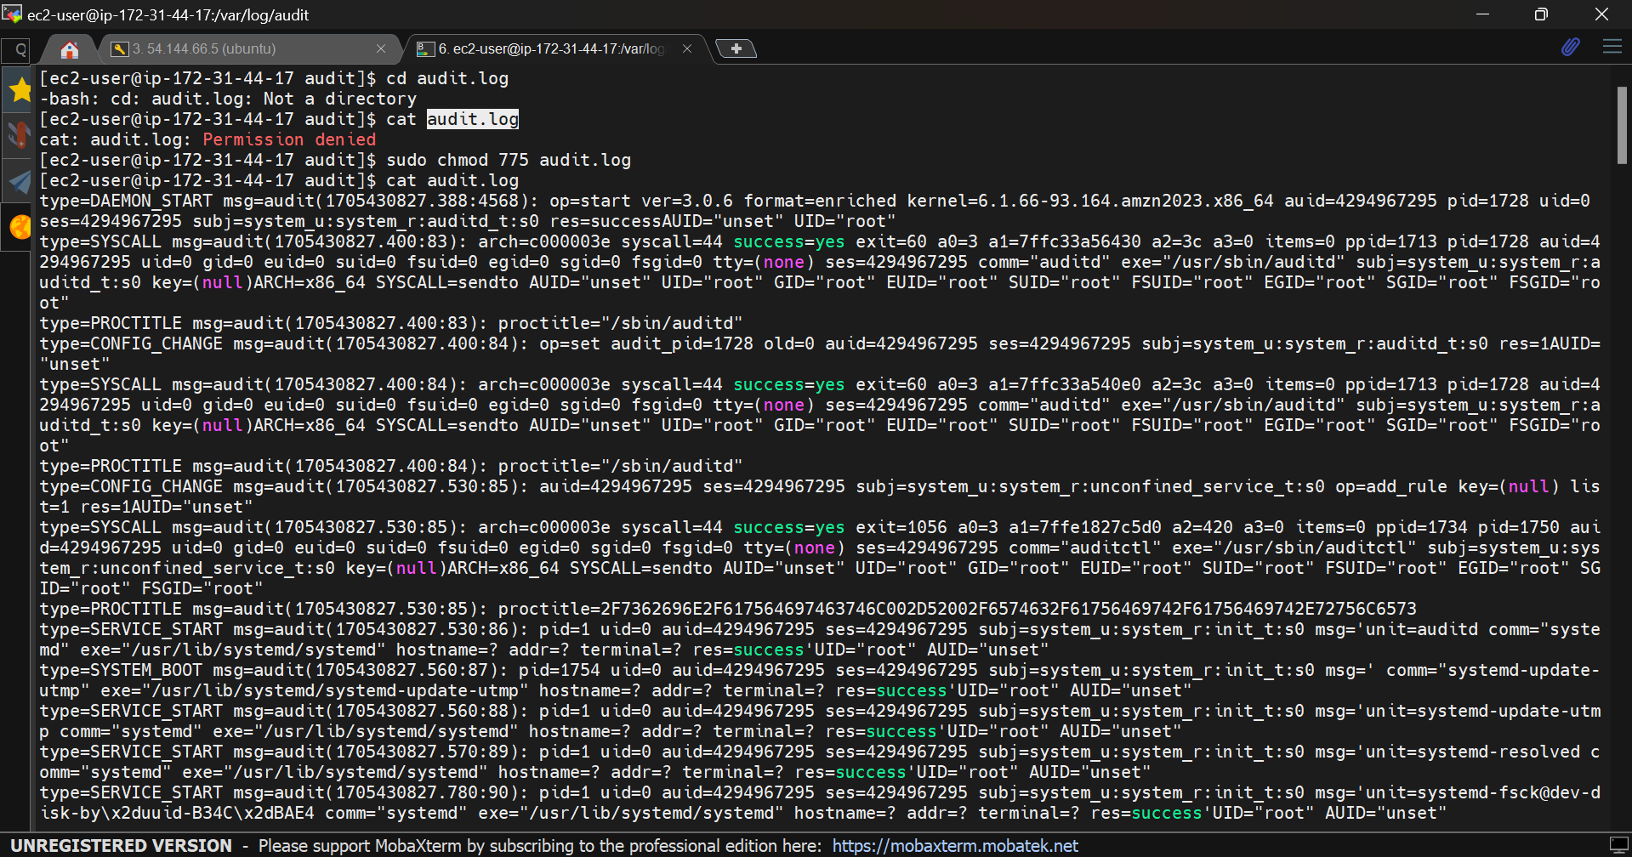

1. Get only todays logs from access.log file

Command: tail -n +10 audit.log | head -n 1

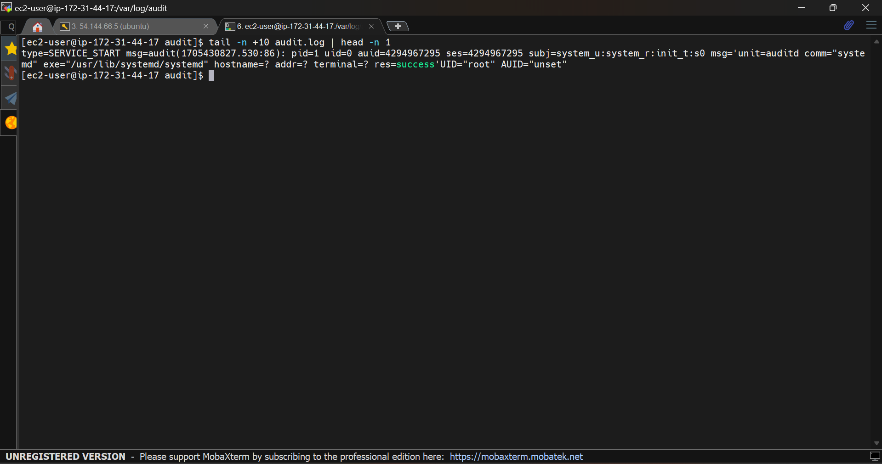

1. Get all ports which are running ( Occupied Ports)

Command : Sudo ss -tuln

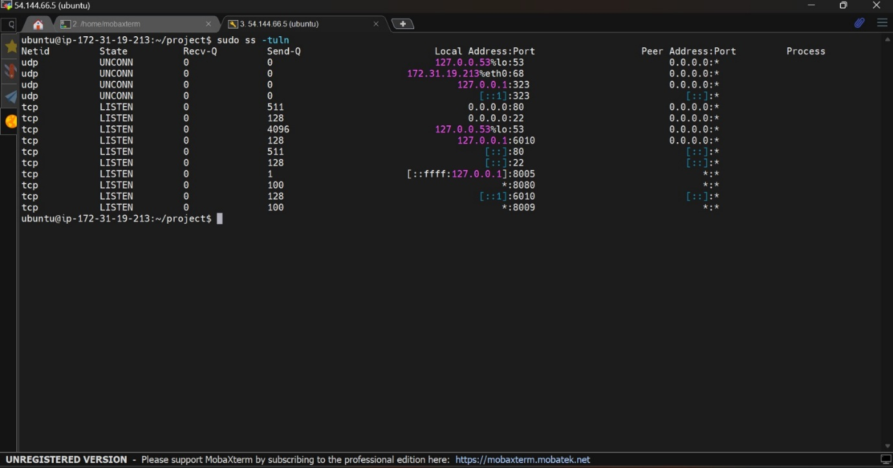

5) Find a file and change permissions

find /path/to/search -name "filename"

find /home/user -name "example.txt"

for permissions : chmod

**01/14/2024:**

1. Create a shell file which includes Installation of Tomcat 9(into new directory) and start tomcat service Execute created shell file which should install and start service

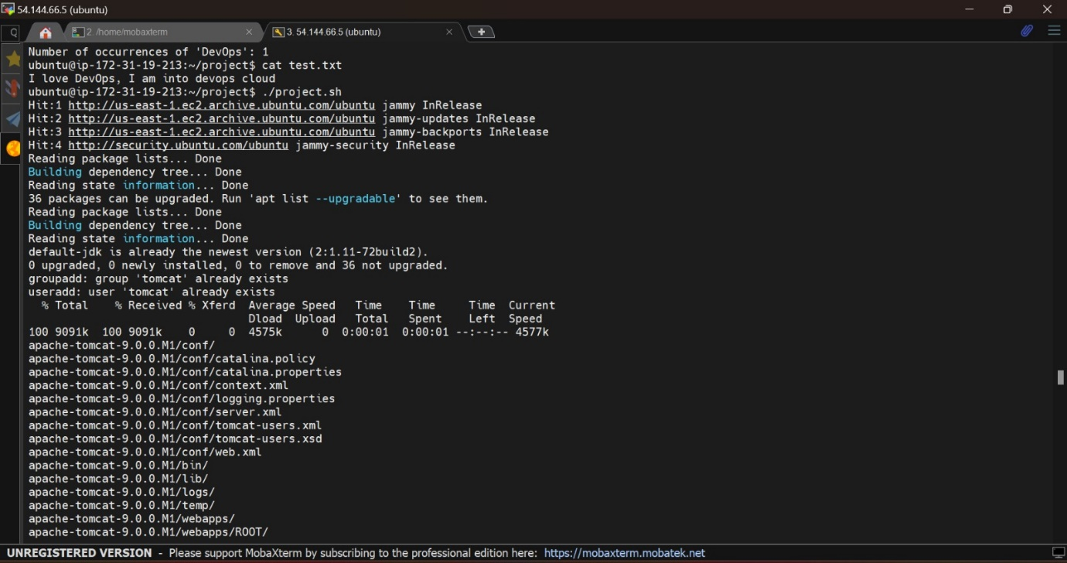

**Note**: Tomcat Requires Java as Pre-requisite and Tomcat runs on Port 8080 by default

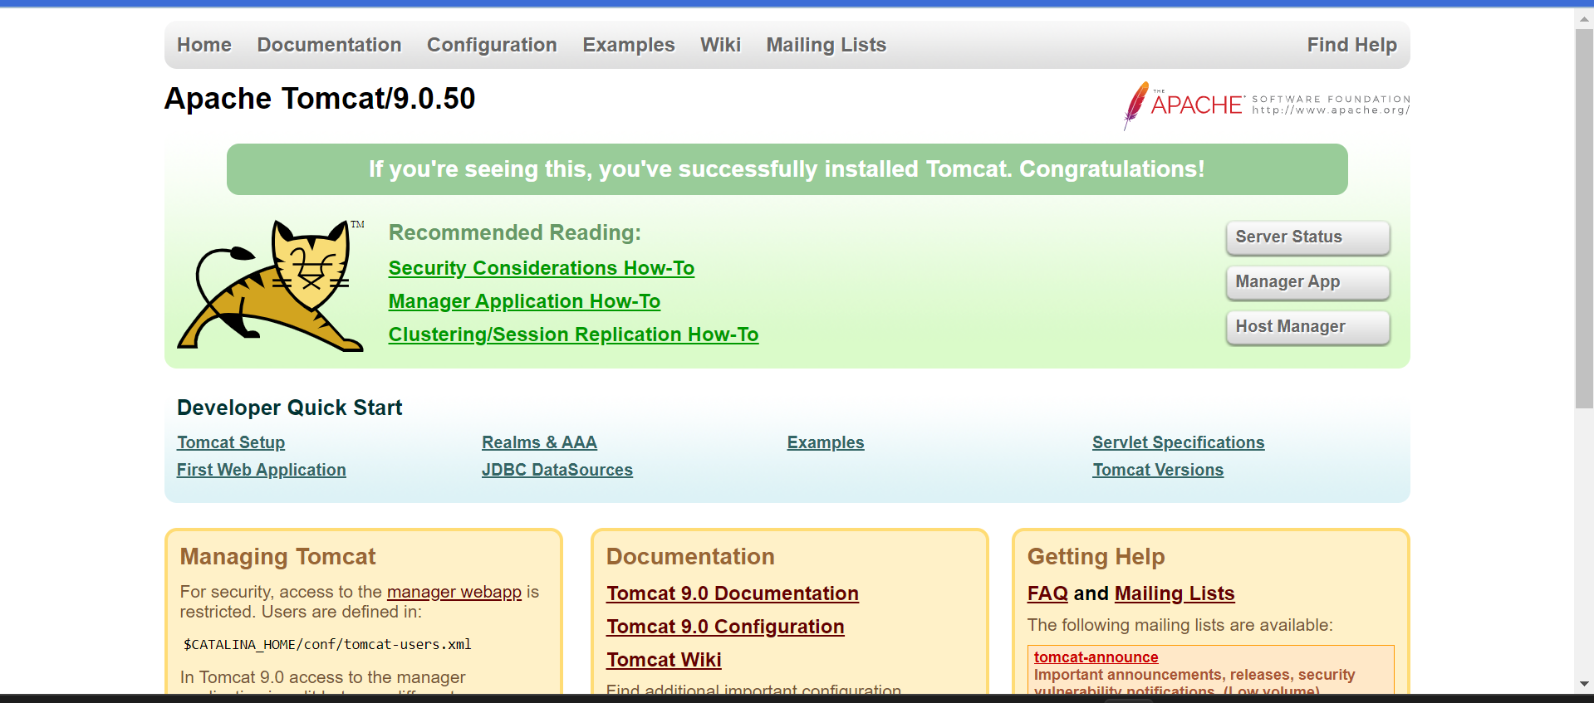

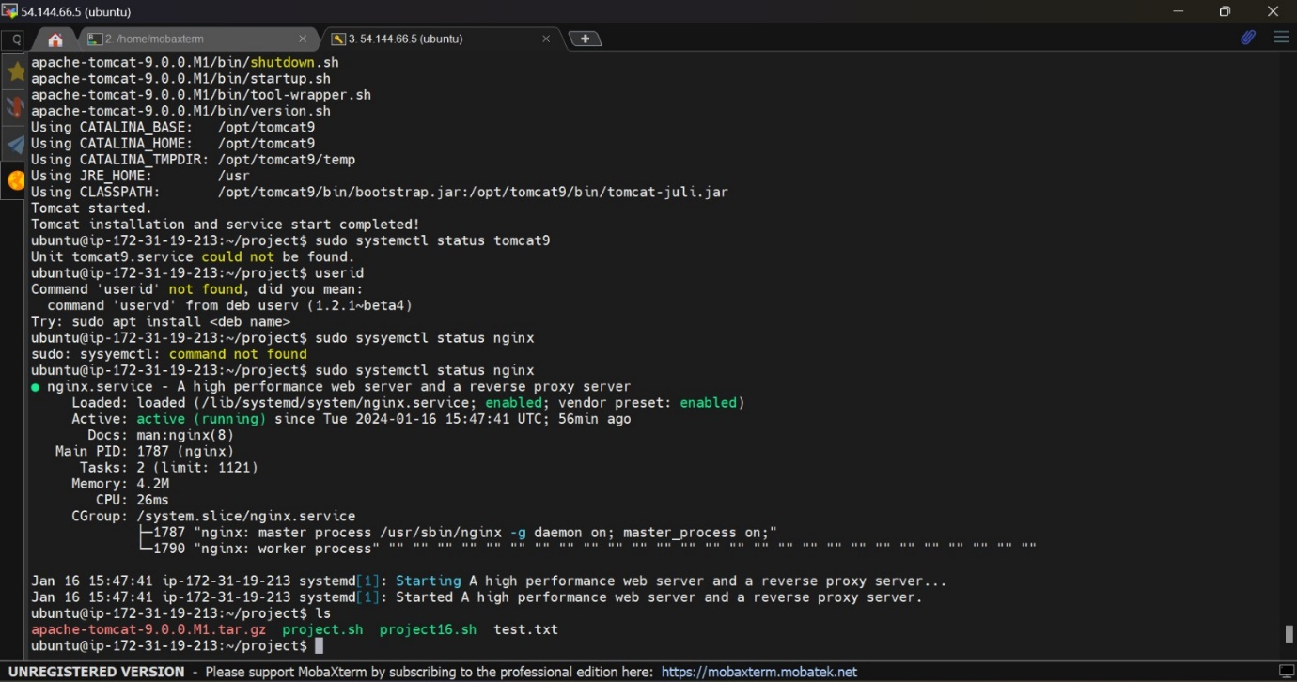2) Create a file (test.txt) with content as ""I love machine, I am into devops cloud"" Write a shell script which has to replace machine into DevOps in above file Then print the no of occurences of devops as output when we execute shell file

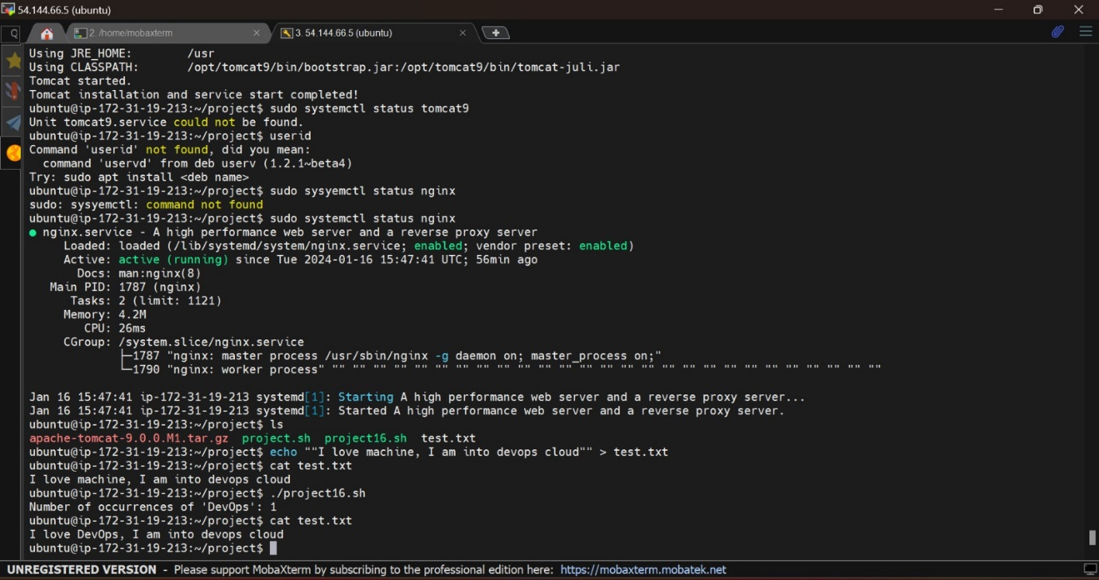

Second way

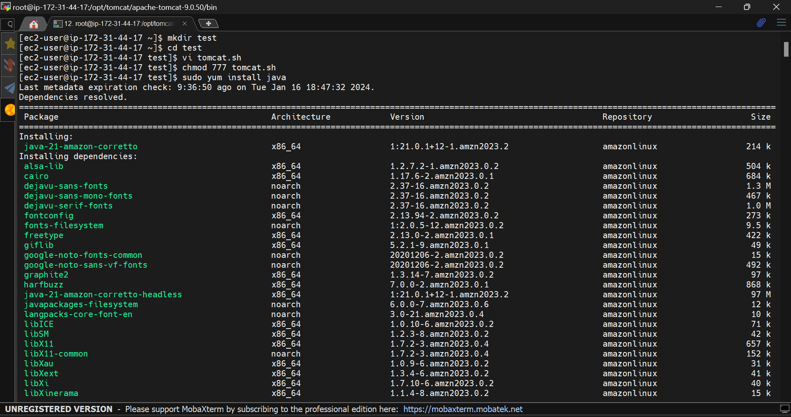

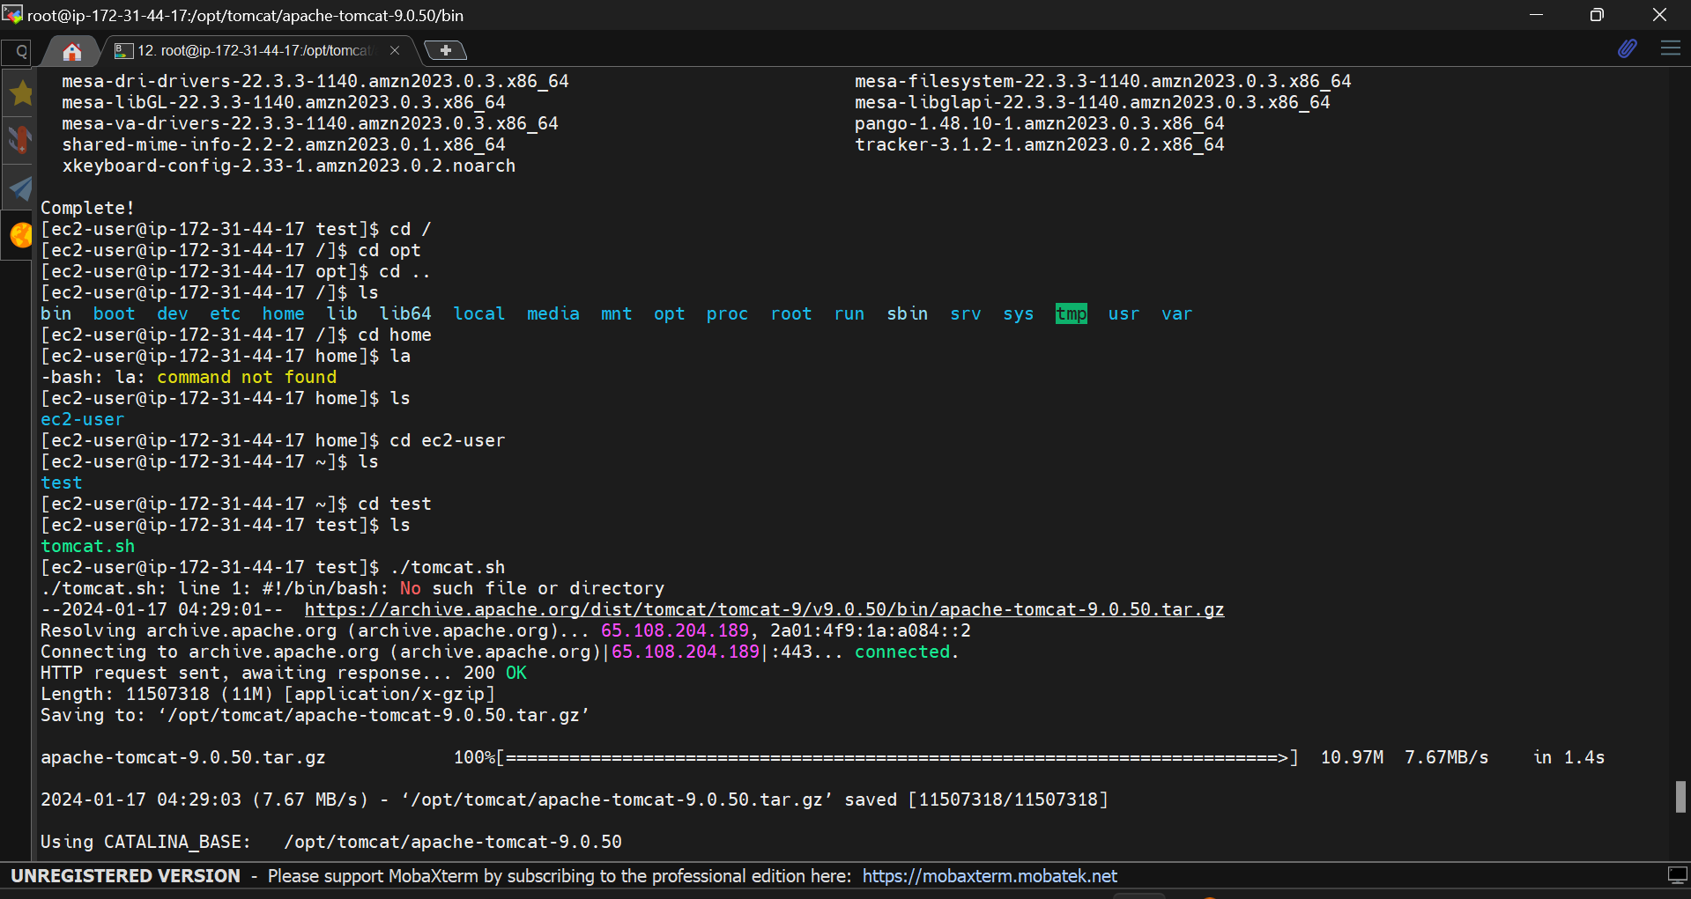

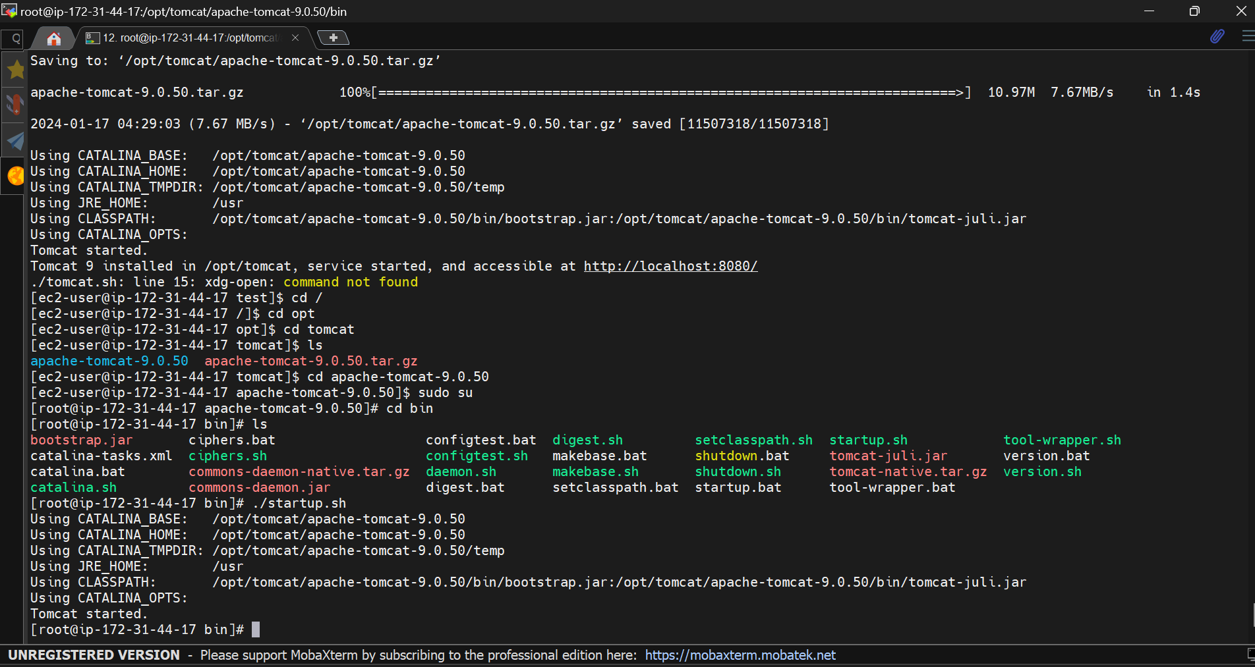

01/15/2024

1. Create ASG with UserData in Launch Template to install nginx and setup min, Desired as 1 and max as 2 with Avg CPU 60



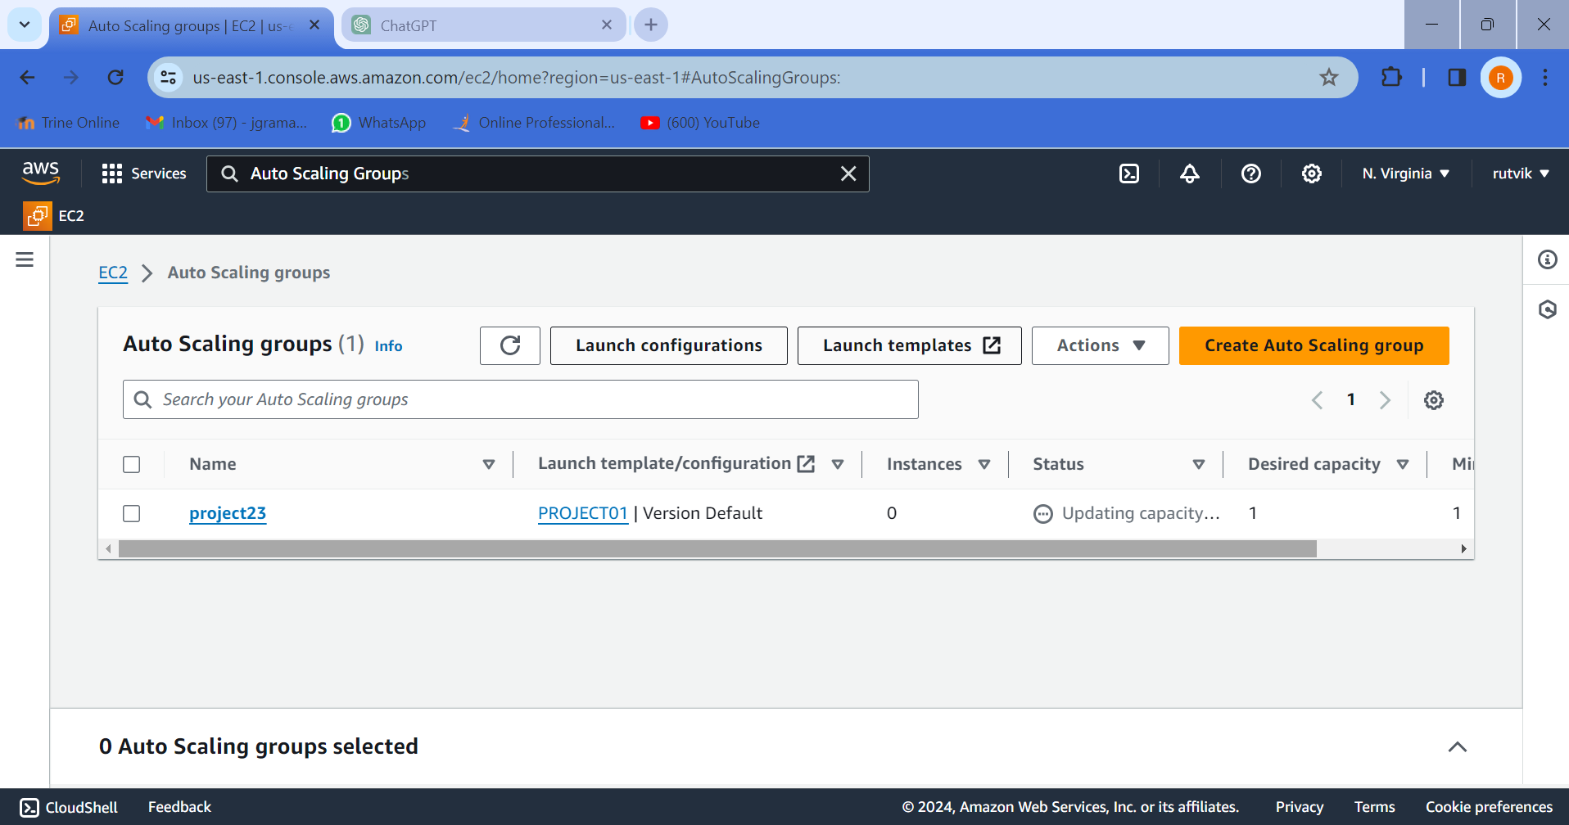

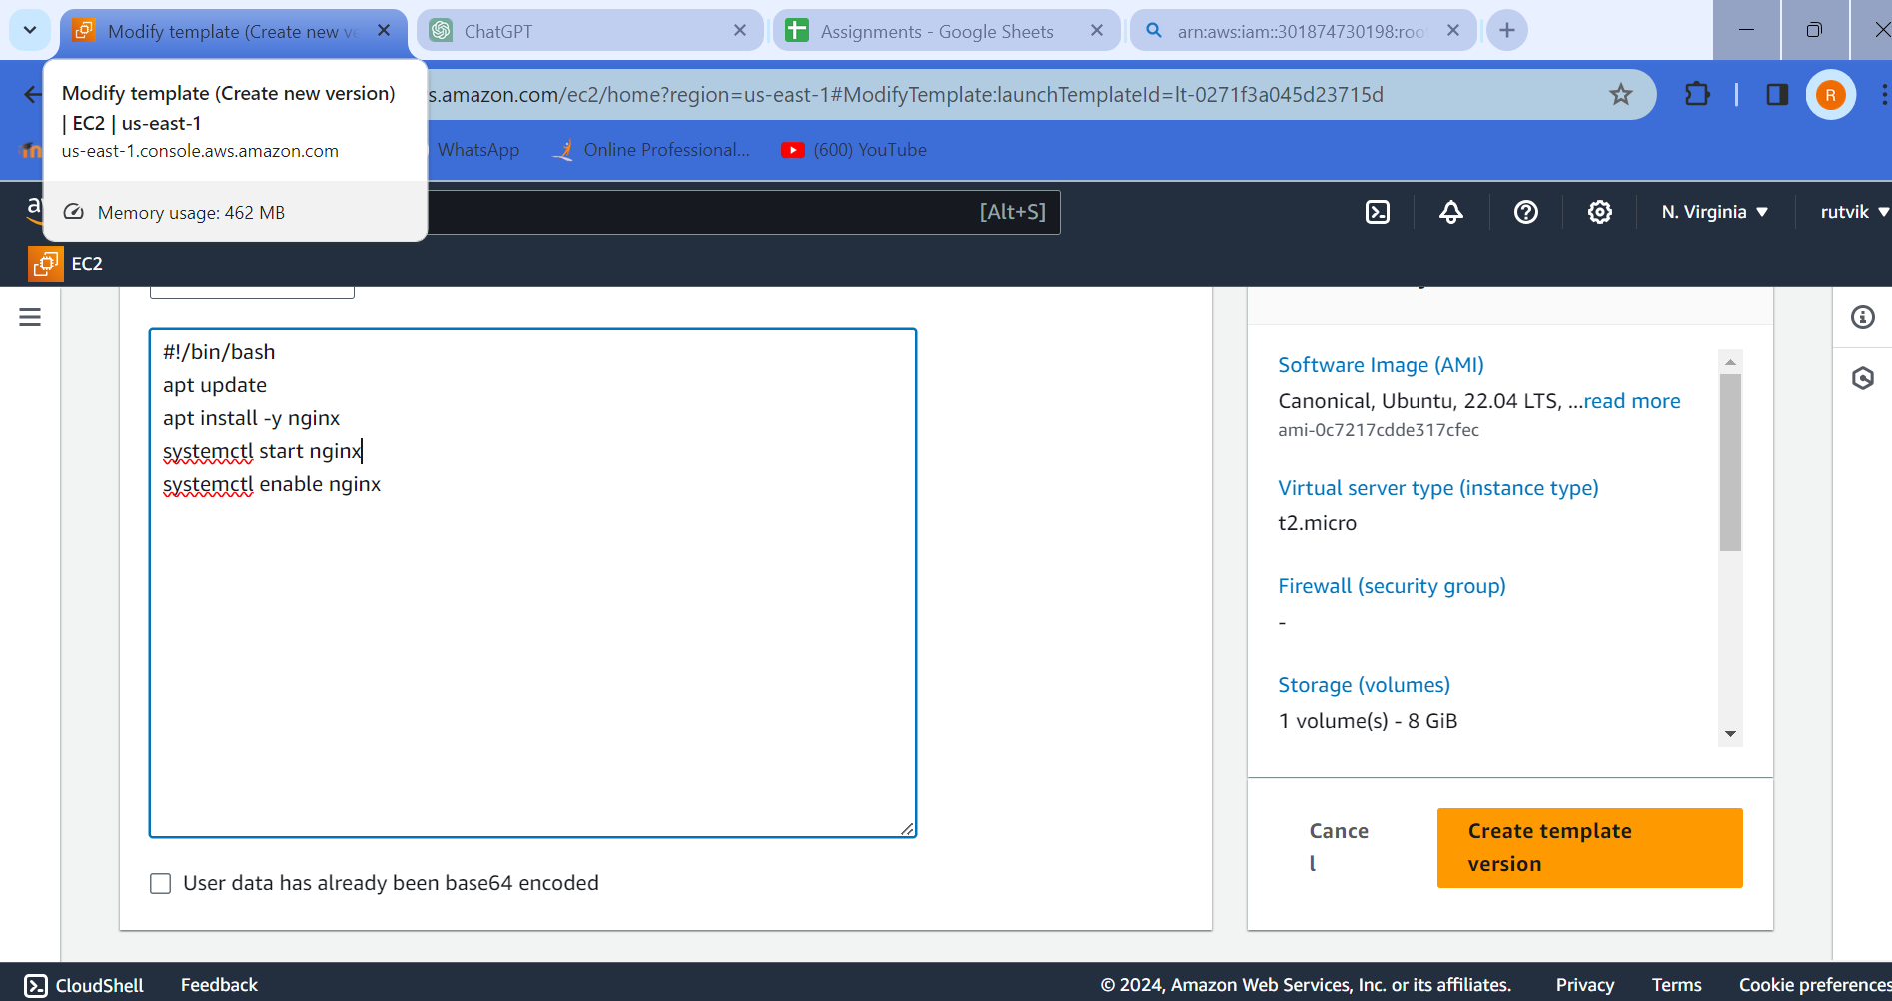

2) Hit ALB DNS and it should distribute traffic to Target Group of Either EC2

3) Download and Install GIT

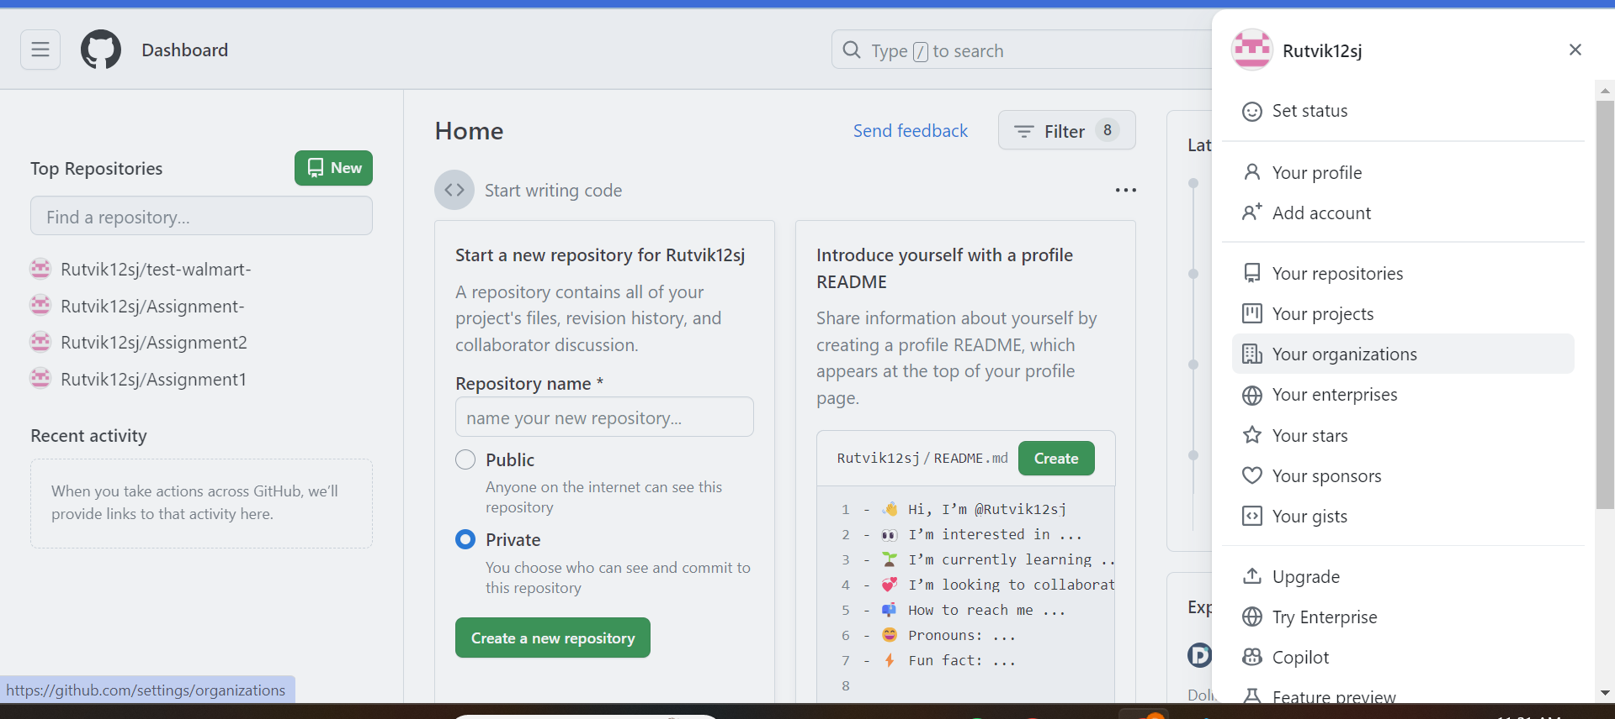

4) Create github account with personal Gmail: [rutvikramani127@gmail.com](mailto:rutvikramani127@gmail.com)

**01/16/2024 : ELB**

Extend Diagram designed on 1/11/24 as above to include ELB and ASG

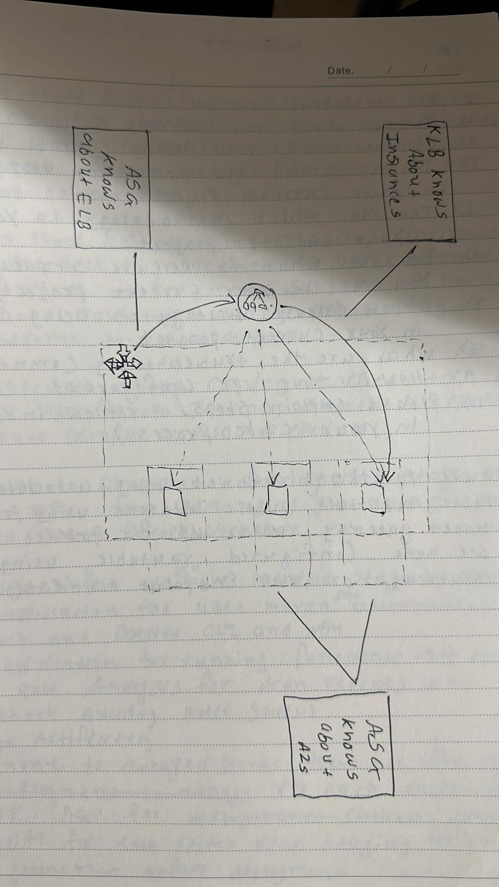

**01/17/2024:** Marketing Questions

Marketing First 5 Questions

**01/18/2024:** Git & Github

Branching Strategy Diagram and Entire Flow

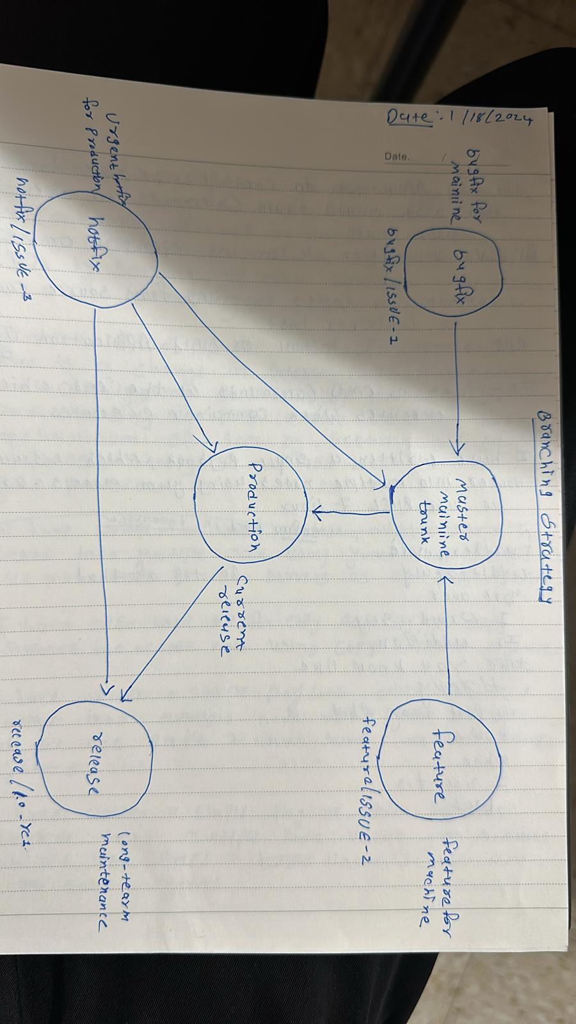

**01/19/2024:** GIT and GitHub

1. create Repo, Clone to Local

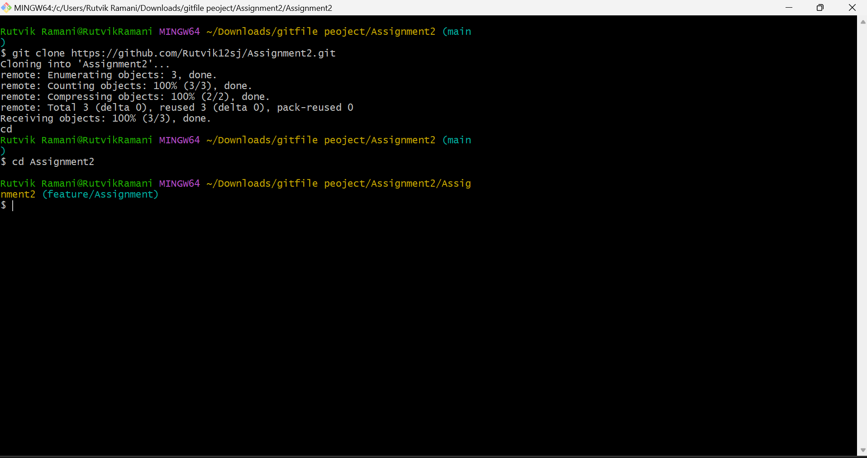

1. Work on 2 Branches and Merge both Branches to develop using PR

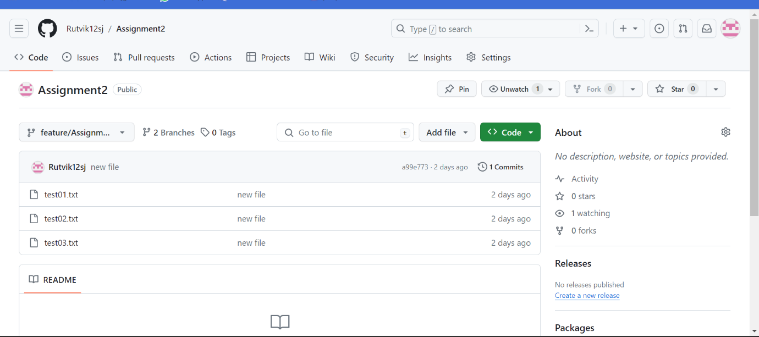

**01/22/2024:**

1. Create Merge Conflict Scenario and resolve Merge Conflicts with 2 branches changed using same file

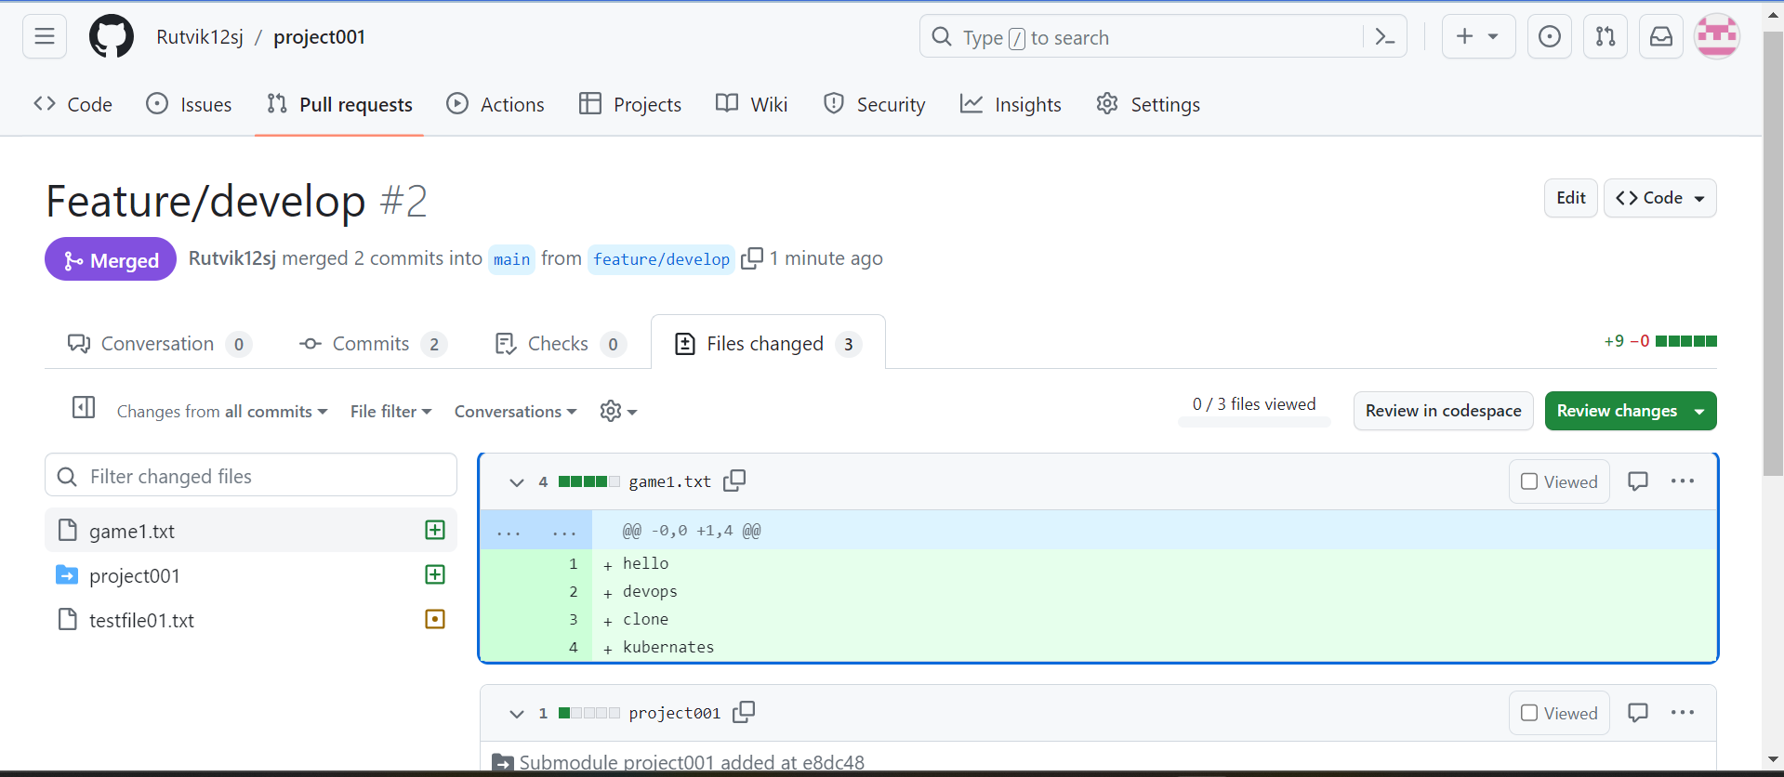

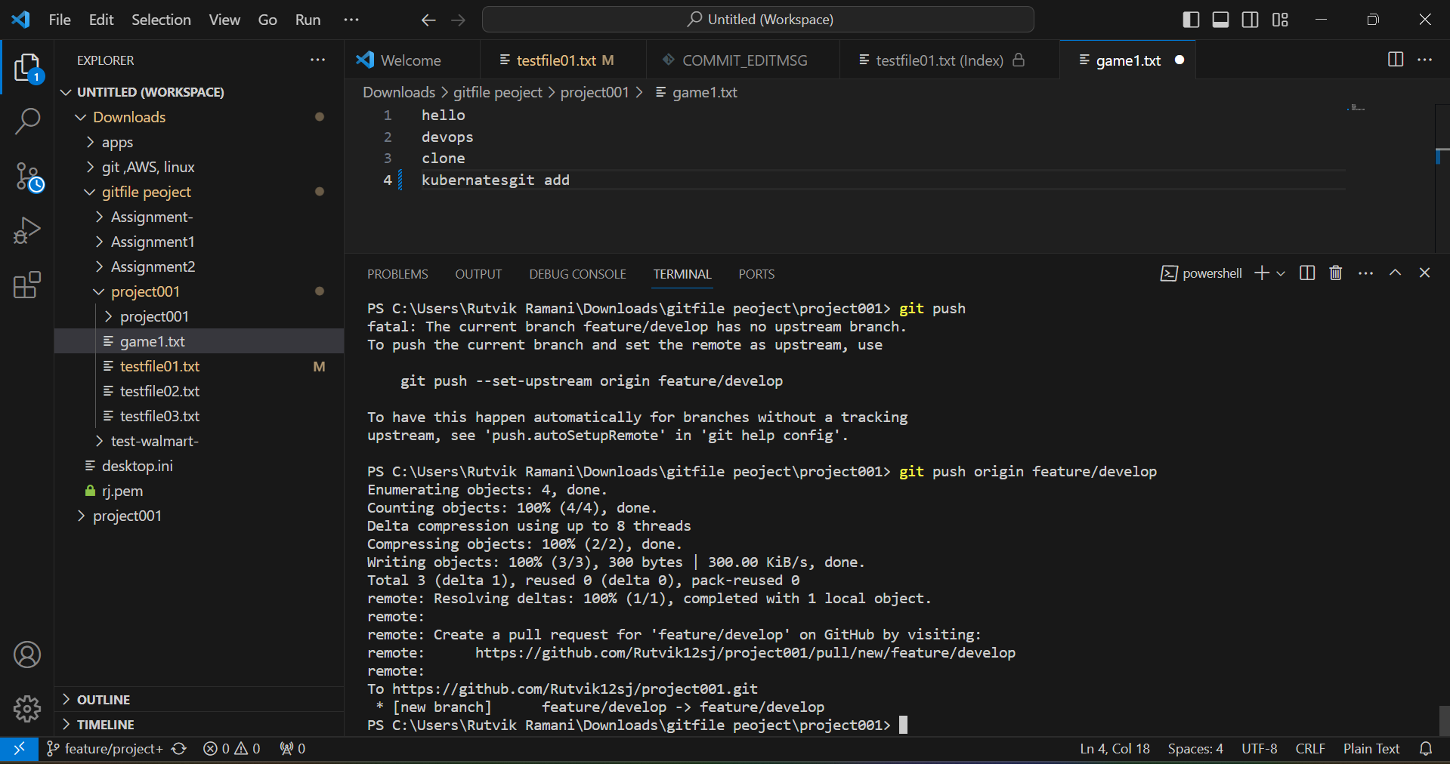

2) Merge vs rebase (observer commit log)

3) git pull vs fetch

**Git fetch vs git pull**

When we do git pullit automatically merges the commits **without reviewing them unless merge conflicts arises.**

**When we do git fetch => It doesn’t get files transferred, it just checks if there are new changes.**

**Git merge vs git rebase**

Merging preserves the entire history of your repository by creating new commit, while rebasing creates a linear history by moving your feature branch onto the tip of main